

Insight Number 1 –

* Reading the whole table

Select * from cars24;

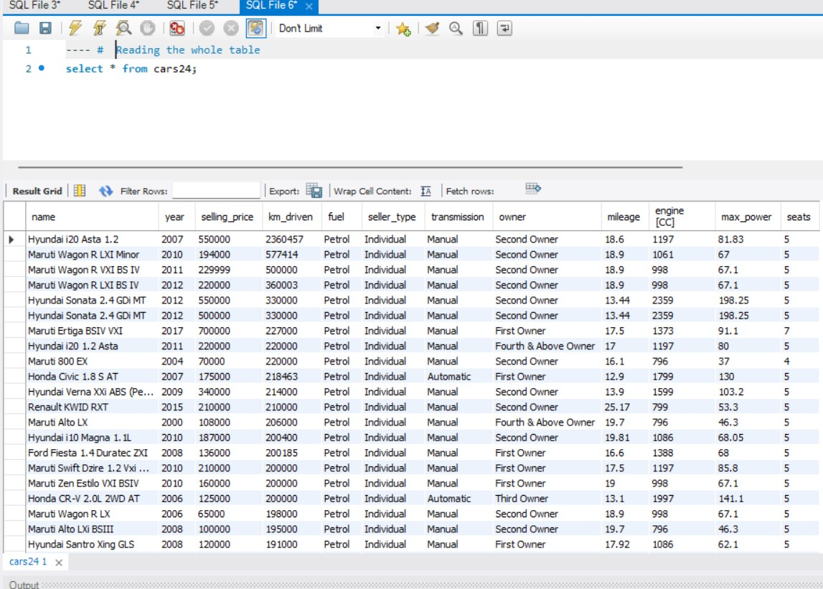

Insight Number 2 –

* Total numbers of cars in inventory

Select count(*) from cars24;

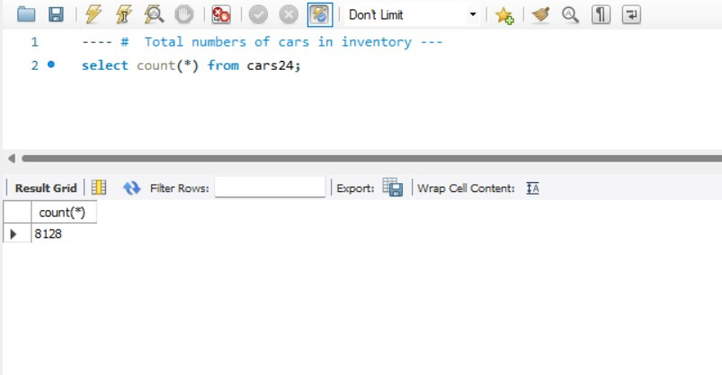

Insight Number 3 –

* Type of cars with name, year, selling price and Max power.

Select name, year, selling_price, max_power,

Case

when max_power > '290' then 'LUXURY'

when max_power between 260 and 289 then 'OFFROADED' when max_power between 180 and 259 then 'SPORTS' when max_power between 100 and 179 then 'SUV' else 'HATCHBACK CAR' END as 'Type' from cars24;

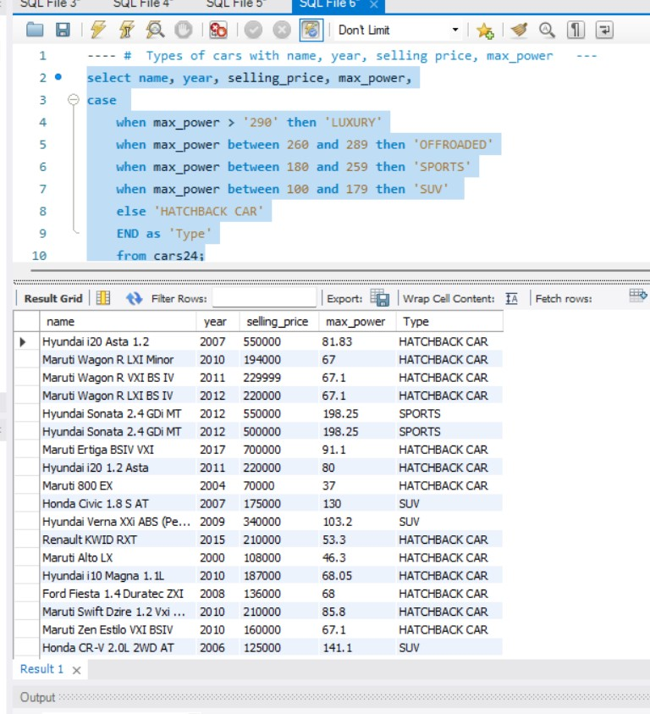

Insight Number 4 –

* Top 5 most expensive cars

Select * from cars24 order by selling_price desc limit 5;

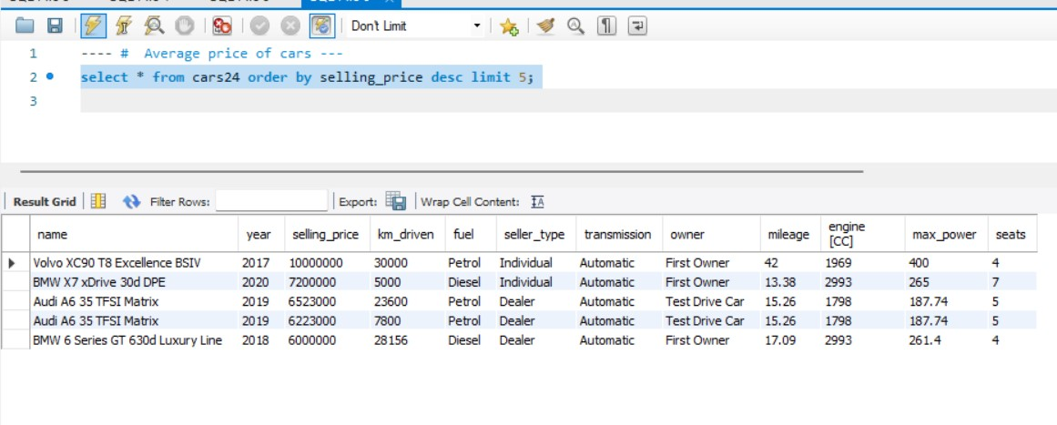

Insight Number 5 –

* Number of cars sold in last year

Select * from cars24 where year = 2020;

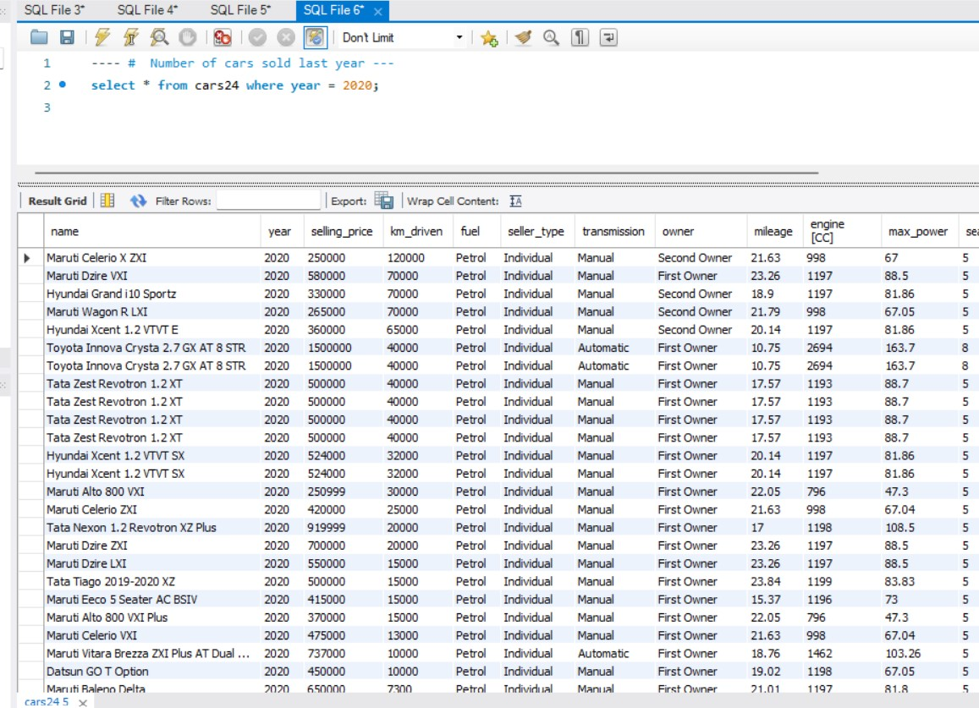

Insight Number 6 –

* Number of cars with name, selling_price and fuel in desc form.

Select name, selling_price, fuel, count(name) as number from cars24 group by 1, 2, 3 order by 2 desc;

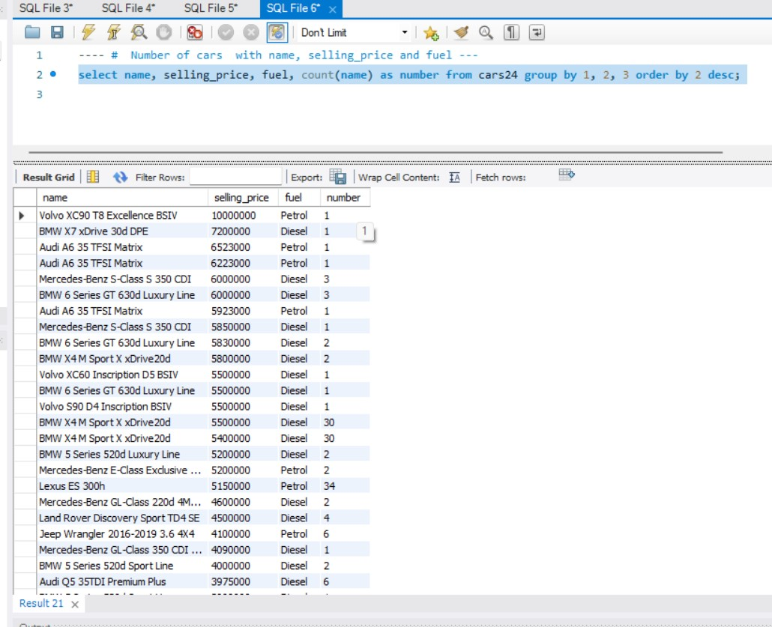

Insight Number 7 –

* Number of cars with manual Transmission

Select count(Transmission) from cars24 where transmission = ‘manual’;

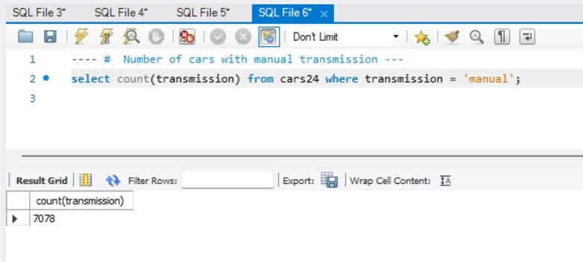

Insight Number 8 – - Number of cars with fuel.

Select fuel, count(fuel) as number from cars24 group by fuel;

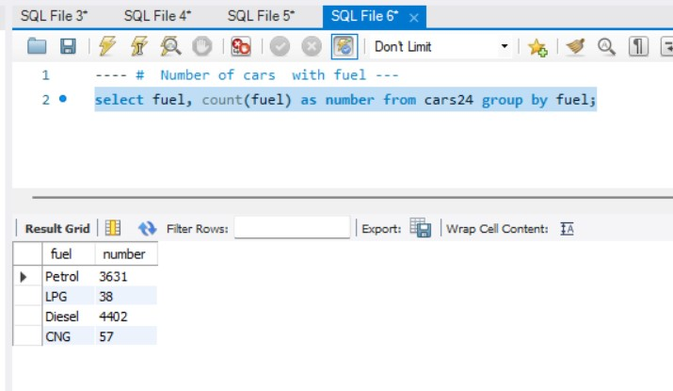

Insight Number 9 –

* List of cars with name Hyundai and Maruti.

Select * from cars24 where name like ‘H%’ or name like ‘M%’;

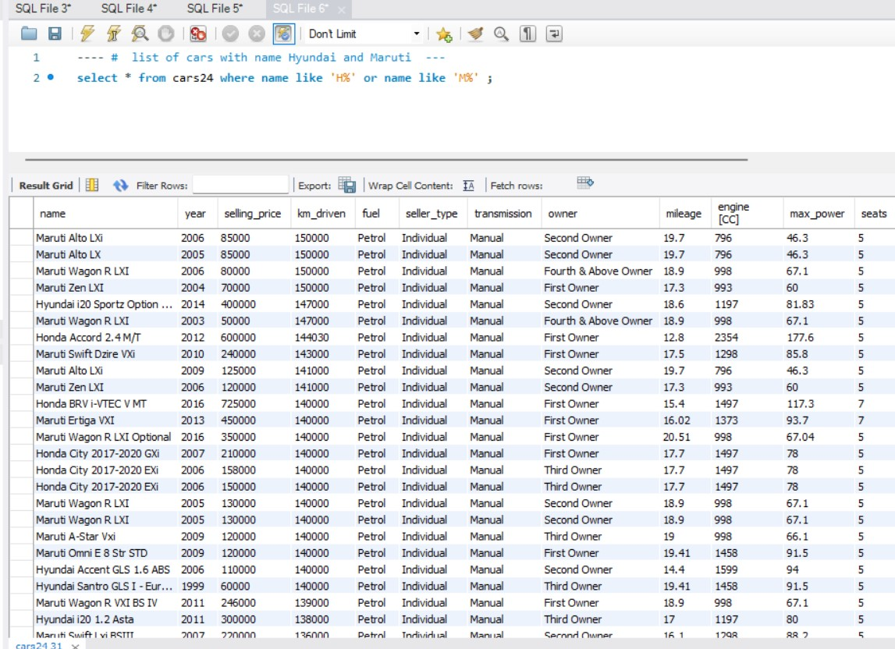

Insight Number 10 –

* List of cars with number of seller_type

Select *, count(seller_type) as type from cars24 group by seller_type;

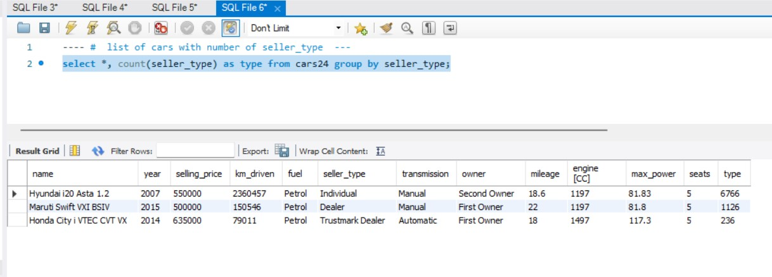

Insight Number 11 –

* Number of cars with name, selling price, km driven and owner.

Select name, selling_price, km_driven, owner, count(owner) as inhand from cars24 group by owner order by inhand;

